|  |  |  |  |  |  |  |
| --- | --- | --- | --- | --- | --- | --- |
|  | **COLÉGIO MARIA JOSÉ DA SILVA MELO** | | | | **Quantitativo** |  |
| **Série: 6º Ano Fund.** | **Professor: Nayara** | **Data:_17/04/2021** | | **Qualitativo** |  |
|  |
| **Nome: Ísis Maria de Morais Ferreira** | | | **Nº** | **NOTA** |  |
| **VERIFICAÇÃO DE APRENDIZAGEM DE INGLÊS** | | | | | | |

**Questão 1**: Preencha as lacunas com o verbo TO HAVE no simple present:

a) Junior ___**has**___ blue eyes.  
b) Melissa ___**has**___ two cats and five dogs.  
c) Lucas and Amanda ___**have**___ three daughters and two sons.  
d) You ___**have**___ a lot of good friends.  
e) My neighbors ___**have**___ a big house.

**Questão 2**: Escreva nas formas negativa e interrogativa a frase abaixo:

***They have a good job.***

NEGATIVA: __**They have not a good job**

INTERROGATIVA: **Do they have a good job ?_**_________________________________________________

**Questão 3: Nas questões abaixo preencha as lacunas com do / don’t ou does / doesn’t.**

a) __**Does**___ Rachel and Jack have kids?

b) We __**don’t**__ have money.

c) _**Do**_ they have a baby?

d) I __**don’t**___ have enough money to buy that car.

e) _**Does**  Bob have enough time to finish his report?

f) _**Do**___ Jack and Tom have dogs?

g) She _**doesn’t**____ have a lot friends.

**Questão 4**: Selecione a forma correta para preencher a frase: **I _am___ Brazilian and I live in Curitiba.**

1. Am
2. Is
3. Isn’t
4. Are

**LETRA A**

**Questão 5:** Em relação à frase **They aren’t single** é correto afirmar que:

a) A sua forma negativa é: they are single.

b) A sua forma interrogativa é: are they single?

c) Cabe reescrevê-la como they isn’t single.

d) Nenhuma das anteriores.

**LETRA D**

**Questão 6:** **Complete a frase “Bob is rich, ___is he__?” com a opção adequada:**

a) is he

b) don’t he

c) isn’t he

d) not he

**LETRA A**

***Com base na imagem abaixo, responda as questões 7ª e 8ª:***

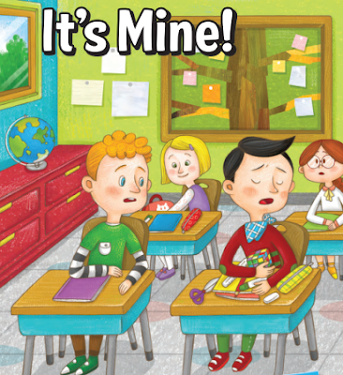

**Questão 7:** Does the boy on the right like to share his things? (O menino à direita gosta de compartilhar suas coisas?)

(   ) Yes, he does.

( X   ) No, he doesn’t.

**Questão 8:** Leia o texto:

**It's mine!**

Pedro hates sharing his things.

“Can I borrow your pen?” his classmate asks.

But Pedro doesn’t want to share.

“I don’t have a pen,” he lies.

His dad is worried and says,

“Sharing is fun! Try it!”

But Pedro doesn’t listen.

One day, Pedro’s class takes a trip.

But Pedro forgets his lunch.

He feels very hungry.

Then his classmate Jenny says,

“Share my food, Pedro.”

He enjoys eating with Jenny.

“Dad was right,” Pedro thinks.

“Sharing is good!”

**VOCABULÁRIO**

**hate:** odiar

**sharing/share:** compartilhar

**borrow:** pedir algo emprestado

**ask:**perguntar

**want:** querer

**have:** ter

**say:** dizer

**lie:** mentir

**worried:**preocupado (com alguém/algo)

**try:** tentar/experimentar

**listen:** escutar

**take a trip:** fazer uma viagem

**forget:** esquecer

**feel:** sentir

**hungry:** com fome/faminto

**enjoy:** gostar/divertir-se

**think:** pensar

**bring:**trazer

Agora, responda: The story is about __**sharing**_ with others. (A história é sobre__**compartilhar**__ com os outros.)

a) speaking

b) sharing

c) studying

d) talking

**LETRA B**

**Questão 9:** Conforme o texto na questão nº 8, marque verdadeiro ou falso. Consulte o vocabulário.

a) Pedro listens to his dad’s advice. **F**

b) Pedro brings his lunch on the class trip. **F**

c) Jenny shares her food with Pedro. **V**

d) Pedro thinks his dad **F**

**Questão 10:** Maria and Fernando __are__ Spanish.

a) is

b) isn’t

c) are

d) am